Artificial Intelligence for Healthcare Specialization
Build the Future of Healthcare with AI. Learn to design, implement, and evaluate responsible AI solutions that improve patient outcomes
What you'll learn
- Describe how to apply machine learning techniques to analyze healthcare data and solve clinical problems
- Evaluate the effectiveness of AI models in healthcare contexts, including performance metrics, clinical validation, and ethical considerations
- Develop predictive models for patient outcomes using supervised and unsupervised learning techniques
- Design and implement neural networks for medical image analysis and clinical decision support systems
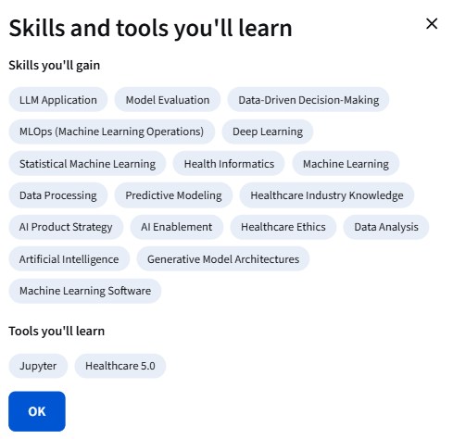

Specialization - 3 course series
Artificial intelligence is transforming healthcare, improving diagnosis, predicting patient outcomes, and enabling precision medicine. This specialization empowers you to turn data into clinical insight through hands-on, healthcare-specific AI applications.
Designed for healthcare professionals, data scientists, and software developers, this intermediate-level specialization teaches how to apply machine learning and deep learning techniques to medical data. You’ll learn to preprocess and analyze electronic health records, build predictive models for patient outcomes, and design AI-driven clinical decision support systems that align with real-world healthcare needs.
Through hands-on labs and projects using real healthcare datasets, you’ll master supervised and unsupervised learning, neural networks for medical image analysis, and population health modeling. The specialization also covers ethical and regulatory considerations, ensuring your AI solutions are safe, interpretable, and clinically meaningful.
By the end of this specialization, you’ll be ready to contribute to roles such as Clinical Data Scientist, Healthcare AI Engineer, or Health Informatics Specialist, helping shape the future of AI-powered healthcare innovation.
Applied Learning Project
This specialization offers hands-on projects that immerse you in real-world healthcare AI applications.
The first project involves developing a machine learning model to detect liver disease using real patient data. You’ll apply data preprocessing, feature selection, model training, and evaluation metrics to assess diagnostic accuracy.
The second project focuses on designing and implementing a complete clinical AI solution for maternal health risk prediction. You’ll integrate supervised and deep learning models, evaluate model performance, and ensure clinical relevance and ethical reliability.
Finally, in the third project, you will create a medical chatbot prototype powered by a biomedical language model. You’ll design a user-friendly interface and demonstrate how conversational AI can support clinicians and summarize medical reports.
These projects provide portfolio-ready deliverables, showcasing your ability to build impactful AI solutions for healthcare.

